Sales Performance Analysis Project

Objective: To analyze sales performance using Superstore dataset to uncover key business insights, sales trends, and profit patterns for better decision-making.

Tools & Libraries Used
• Python – Programming language
• Pandas – Data manipulation and cleaning
• NumPy – Numerical computation
• Matplotlib & Seaborn – Data visualization
• Google Colab – Coding environment

Project Overview
This project focuses on analyzing Superstore Sales Data using Python libraries — Pandas, NumPy, Matplotlib, and Seaborn — to identify patterns, trends, and performance metrics.
The dataset includes sales transactions, customer details, order information, and product-level data.

Dataset Description
Dataset Name: Sales Data (Excel file: sales data.xlsx)

Columns present in dataset:
• Row ID: Unique row identifier
• Order ID: Unique order identifier
• Order Date: Date when the order was placed
• Ship Date: Date when the order was shipped
• Ship Mode: Type of shipping (e.g., Standard Class, First Class)
• Customer ID: Unique customer identifier
• Customer Name: Name of the customer
• Segment: Customer segment (Consumer, Corporate, Home Office)
• Country: Country name
• Region: Region where order was delivered
• City: City of delivery
• State: State of delivery
• Postal Code: Area code
• Product ID: Unique product identifier
• Category: Product category (Furniture, Technology,
Office Supplies)
• Sub-Category: Subdivision of category
• Product Name: Name of the product sold
• Sales: Total sales amount
• Quantity: Number of units sold
• Discount: Discount given
• Profit: Profit earned on each sale
Data Preparation and Cleaning
• Imported libraries (pandas, numpy, matplotlib, seaborn)
• Loaded the dataset using pd.read_excel()
• Displayed first few rows using head()
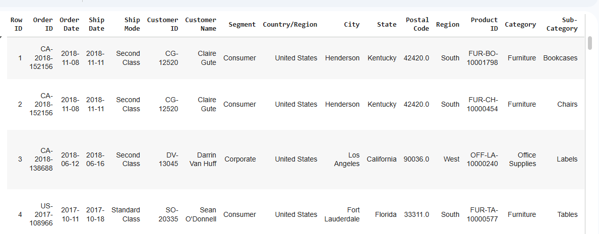
• Checked dataset structure using info()
• Checked for missing and duplicate values
• Converted Order Date and Ship Date to datetime format
• Extracted Order Year and Order Month for time-based analysis
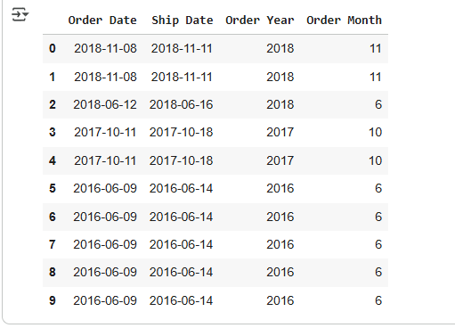
Feature Engineering

a. Profit Category
Created a new column Profit Category to classify profit levels into:
• High: Profit greater than 100
• Medium: Profit greater than 0 but less than or equal to 100
• Low: Profit less than or equal to 0

This helps in understanding product and regional profitability distribution.

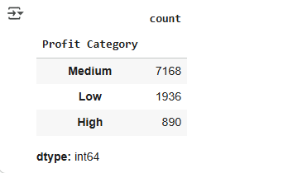

b. Sales After Discount
Used NumPy to calculate the final sales value after discount:
{Sales After Discount} =Sales * (1 -Discount)
Rounded to 2 decimal places for better readability.
c. High Sales Flag
Created a flag column to identify high-value sales transactions:
• Yes if sales amount > 500
• No otherwise

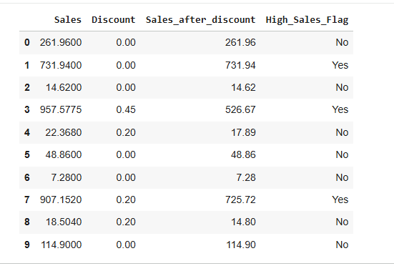

Exploratory Data Analysis (EDA)

a. Top 5 Products by Total Sales
Identified the top 5 products contributing the most to overall sales using groupby and sorting.

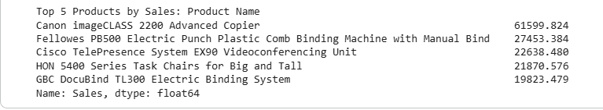

b. Sales Trends Over Years
Grouped total sales by Order Year and plotted a line chart to visualize growth or decline trends across years.

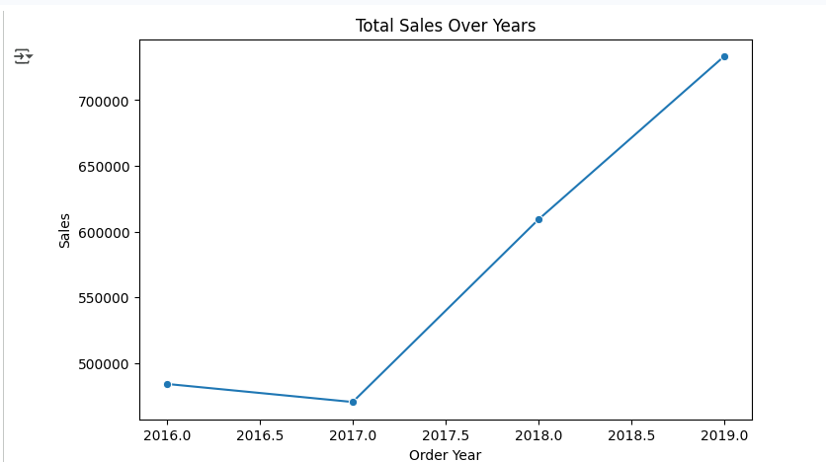

c. Category-wise Sales and Profit Analysis
• Aggregated total sales and profit for each Category
• Visualized with bar charts using Seaborn (sns.barplot)
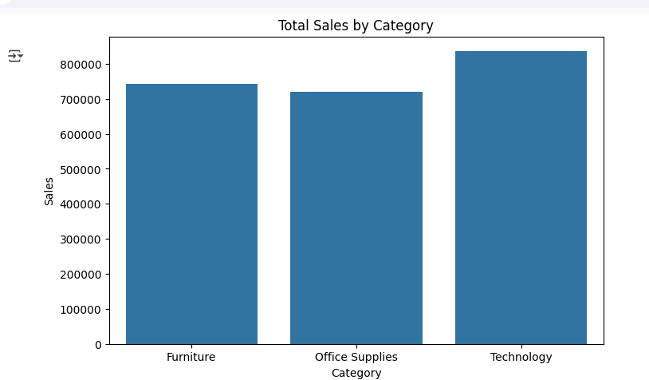
c. Profit Distribution by Segment
Plotted profit distribution across customer segments using boxplot to understand variation and outliers.
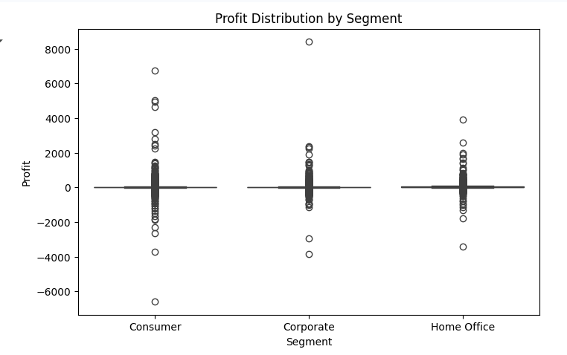
d. Sales Trends Over Years
Grouped total sales by Order Year and plotted a line chart to visualize growth or decline trends across years.

Key Insights
1. Top Products: Certain technology and office supply items contribute the most to sales.
2. Profitable Segments: The Corporate and Consumer segments generate consistent profit margins.
3. Seasonality: Orders peak in specific months, showing potential seasonal demand.
4. Regional Trends: Some regions outperform others in both sales and profitability.
5. Profit Distribution: There is high variability in profit margins across different product categories.

Conclusion

The Superstore Sales Analysis provides actionable insights for improving marketing strategies, optimizing inventory, and maximizing profit.
Using core Python data analysis libraries, we successfully demonstrated:
• Data cleaning and transformation
• Feature engineering
• Exploratory visualization
• Logical and statistical insight generation

